./

Learning Report – Automotive systems and overview

Course Code: <CODE>



Version Number:

Team Members :

Team No:

Module: Model Based System Engineering

|  |  |  |  |  |  |
| --- | --- | --- | --- | --- | --- |
| **Ver. Rel. No.** | **Release Date** | **Prepared. By** | **Reviewed By** | **Approved By** | **Remarks/Revision Details** |
| 1 | 19/03/2021 | Pushkar Antony |  |  |  |

**Document History**

# 

Contents

1. INTRODUCTION: 4

1.1 FEATURES 4

1.2 REASEARCH & LITERATURE SURVEY 5

1.2.1 LITERATURE SURVEY 5

1.2.2 MY FEATURE 5

1.2.3 INPUTS 5

1.2.4 ALGORITHM (Flow Chart) 8

1.2.5 OUTPUT 8

1.2.6 SWOT ANALYSIS 9

1.2.7 DETAILED REQUIREMENTS 10

2. DESIGN & IMPLEMENTATION: 11

2.1 HIGH LEVEL DESIGN & IMPLEMENTATION 11

2.2 LOW LEVEL DSEIGN & IMPLEMENTATION 11

3. TEST PLAN: 12

# **INTRODUCTION**:

* 1. FEATURES:
     1. CRUISE CONTROL:

Cruise control is a system that automatically controls the speed of a motor vehicle. The system is a servomechanism that takes over the throttle of the car to maintain a steady speed as set by the driver. The model selected for this project is 2020 GMC Sierra Denali.

Cruise control system provides automatic speed incrementation and decrementation of vehicle without the usage of gas pedal. Vehicles with wire drive systems use the same actuator to operate the cruise control. The actuator unit is connected to the throttle valve and controls the throttle butterfly position under the command of the cruise control ECU. Actuator mechanisms normally use either a permanent magnet DC motor assembly or a vacuum diaphragm powered by a motor-driven pneumatic pump and controlled by solenoid valves or, in many cases, a vacuum operated diaphragm controlled by three simple valves.

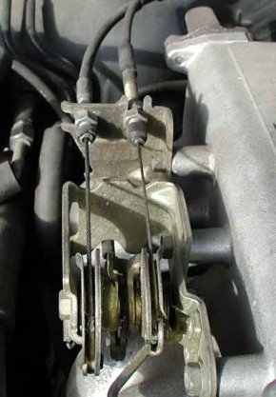

Figure 1: One wire from actuator and another from gas pedal.

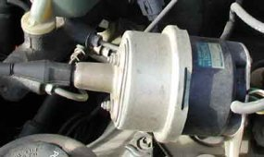

Figure 1.1: Cruise control Actuator

* + 1. HATCH CONTROL:

In automotive electronics, **body control module** or 'body computer' is a generic term for an electronic control unit responsible for monitoring and controlling various electronic accessories in a vehicle's body. Typically, in a car the BCM controls the power windows, power mirrors, air conditioning, immobilizer system, central locking, etc. The BCM communicates with other on-board computers via the car's vehicle bus, and its main application is controlling load drivers – actuating relays that in turn perform actions in the vehicle such as locking the doors or dimming the interior lighting. The distinguishing feature of a hatchback is a rear door that opens upwards and is hinged at roof level (as opposed to the boot/trunk lid of a saloon/sedan, which is hinged below the rear window). Most hatchbacks use a two-box design body style, where the cargo area (trunk/boot) and passenger areas are a single volume. The rear seats can often be folded down to increase the available cargo area. Hatchbacks may have a removable rigid parcel shelf,or flexible roll-up cover to cover the cargo space behind the rear seats

* + 1. AC CONTROL:

Air conditioning is the technology for indoor and automotive ambient comfort. AC facilitates in managing the pleasant climate inside the cabin by controlling the degree of coolness. To understand this just consider the one model of car and go into how it works. I’m taking GMC sierra to explain how the AC system works.

* + 1. SUNROOF CONTROL:

A sunroof is a movable panel that opens to uncover a window in an automobile roof, allowing light and/or fresh air to enter the passenger compartment. Sunroofs can be manually operated or motor driven, and are available in many shapes, sizes and styles. While the term sunroof is now used generically to describe any glass panel in the roof, the term "moonroof" was historically used to describe stationary glass panes rigidly mounted in the roof panel over the passenger compartment. A moonroof has a glass panel that is transparent and usually tinted. Previous terms include Sunshine Roof, Sliding Head and Sliding Roof

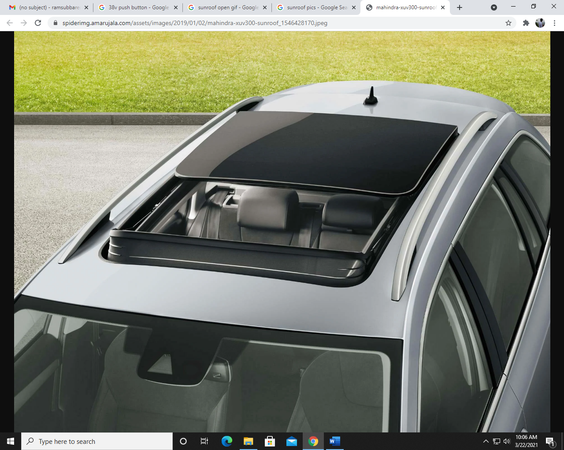

Source: Google image

Fig.1: Sunroof image

* + 1. WIPER CONTROL:

In today’s automotive industry, the issue of driver safety and comfort is of great importance. An automatic windshield wiper system is of great aid in such cases. It betters the driving experience and improvises the safety factor of a vehicle by converting the manual windshield wiper system into an automatic system. By taking care of the attentions drivers would have to devote to control a manual system, an automatic wiper system helps them to concentrate more on driving safely. Although, few automated windshield wiper systems are available in the automotive market, they are very costly and not very effective. This project a cost effective and high performance automatic windshield wiper system developed using an Arduino Uno microcontroller and a rain intensity detection sensor. The system was programmed to use fuzzy logic to manipulate the analog data collected from the sensor, and the microcontroller controlled the wiper motor using pulse width modulation (PWM). The use of fuzzy logic allows the system to be easily reconfigurable. Such feature can be utilized to design different wiper system for different vehicles and weather conditions without any hardware modification.

* 1. REASEARCH & LITERATURE SURVEY:
     1. LITERATURE SURVEY:
* GMC SIERRA DENALI Owner’s manual 2020

PDF link:

<https://cdn.dealereprocess.org/cdn/servicemanuals/gmc/2020-sierra1500.pdf>

* “Cruise Control Operation from Zero to Preset Speed-Simulation and Implementation” by F. A. Arvind Raj R., S. B. Sandhiya Kumar, Member IACSIT, IEEE and T. C. Karthik S.

Paper Link: <http://www.ijiet.org/papers/2-W13.pdf>

* + 1. MY FEATURE:

In the cruise control feature I am building, I have taken a Level 1 cruise control. Here, there are 4 inputs and 1 output. The model I am taking for reference is the GMC SIERRA DENALI 2020 model.

* + 1. INPUTS:
       1. USER INPUT:
       - Cruise control on/off: Press to turn cruise control on or off.
       - +RES: If there is a set speed in memory, press the control up briefly to resume to that speed or press and hold to accelerate. If cruise control is already engaged, use to increase vehicle speed.
       - SET-: Press the control down briefly to set the speed and activate cruise control. If cruise control is already engaged, use to decrease the vehicle speed.
       - Disengage cruise with set memory: It disengages the cruise control without erasing the set speed from memory.

This user input is achieved using push buttons.

Full Datasheet Link: <https://cdn.dealereprocess.org/cdn/servicemanuals/gmc/2020-sierra1500.pdf>

Ex: Waytek round push button switch 44102

Characteristics:

* + - * Supply voltage: 14VDC
      * Supply current: 20A
      * IP65
      1. SENSOR INPUT:

Throttle Position sensor(TPS): The throttle is a valve mechanism allowing to modify the amount of gas flow into the cylinders of a gasoline internal combustion engine. The throttle is actuated directly by the driver through the gas pedal, and accordingly there was a mechanical connection between the two. The throttle position is mapped with the speed of the vehicle.

Input to the Sensor: Voltage (typically <25V, varies from sensor to sensor).

Sensor Output: Voltage (the peak voltage varies based on the sensor type and is proportional to the speed).

There are 3 types of TPS:

* + - * Potentiometric TPS Measurement: Potentiometers are widely used as a cheap means for measuring rotational positions.

Example: PC-PTN

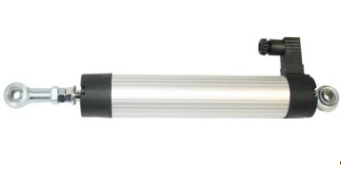

Figure 1.3: Potentiometric TPS

Full Datasheet Link: <https://www.position-control.de/wpcontent/uploads/2016/09/Datasheet_PC_PTN.pdf>

Characteristics:

* Supply Voltage: 24VDC
* Output Voltage: 0-10VDC
* Output Current: 4-20mA
* Temperature range: -30°C to +100°C
* Life: 100 million movements
  + - * Inductive TPS Measurement: One way of measuring a rotational position in a contactless way is by using an inductive principle. Transmit coils send a signal, which is coupled back through a rotor into receiver coils.

Example: LX3302

Full Datasheet Link: <http://static6.arrow.com/aropdfconversion/b3010cd8c0c5ab0b28a10c4470af4a9918099493/7527135720-lx3302-datasheet.pdf>

Characteristics:

* Supply Voltage: 20V
* Operating Temperature: -40°C to +150°C
* Supply Current: 10mA
* Operating humidity: 0-95
* Frequency: 8.4 MHz
  + - * Magnetic TPS measurement: Hall-effect based magnetic sensors, fully integrated on silicon, have since achieved a considerable share in this application.

Example: 981 HE

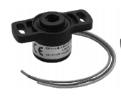

Figure 1.4: Hall-effect TPS

Full Datasheet Link: [https://docs.rs-online.com/68d1/0900766b80fe81c1.pdf](https://docs.rs-online.com/68d1/0900766b80fe81c1.pdf%20)

Characteristics:

* Supply Voltage: 5VDC
* Supply Current: 10mA
* Weight: 19g
* Linearity: 1%
* Mechanical travel: 360°
  + 1. ALGORITHM (Flow Chart):

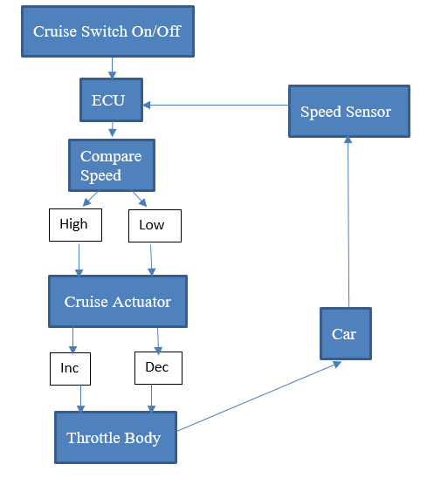

Algorithm for cruise control

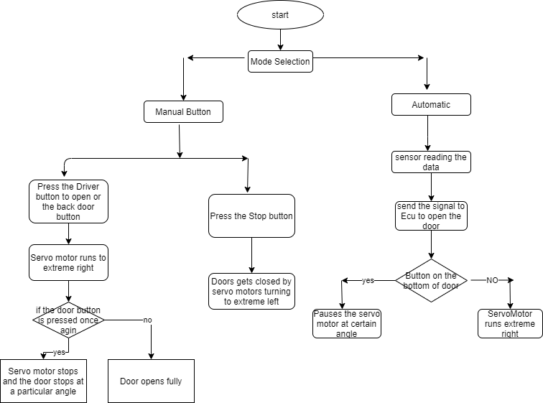

Algorithm for Hatch opening

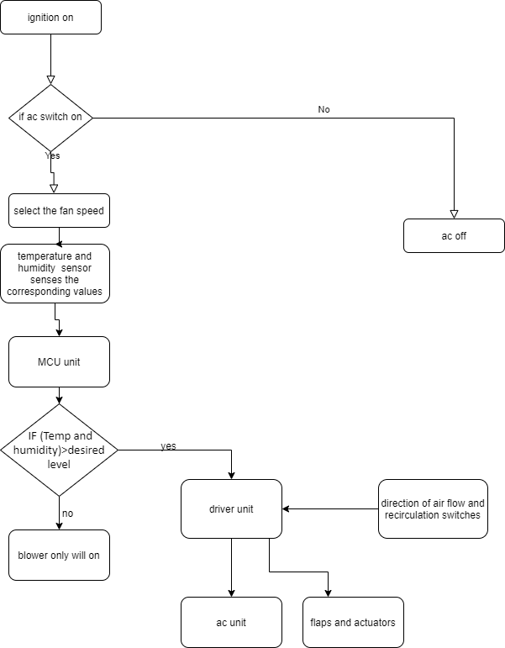

Algorithm for AC control

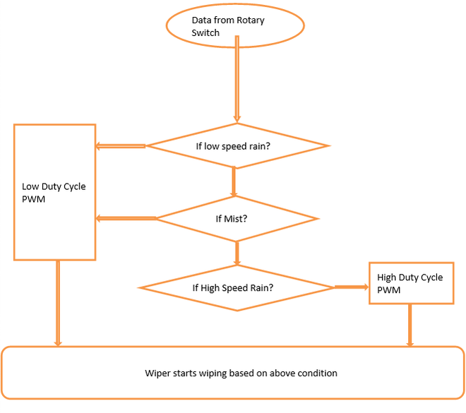

Algorithm for Wiper control

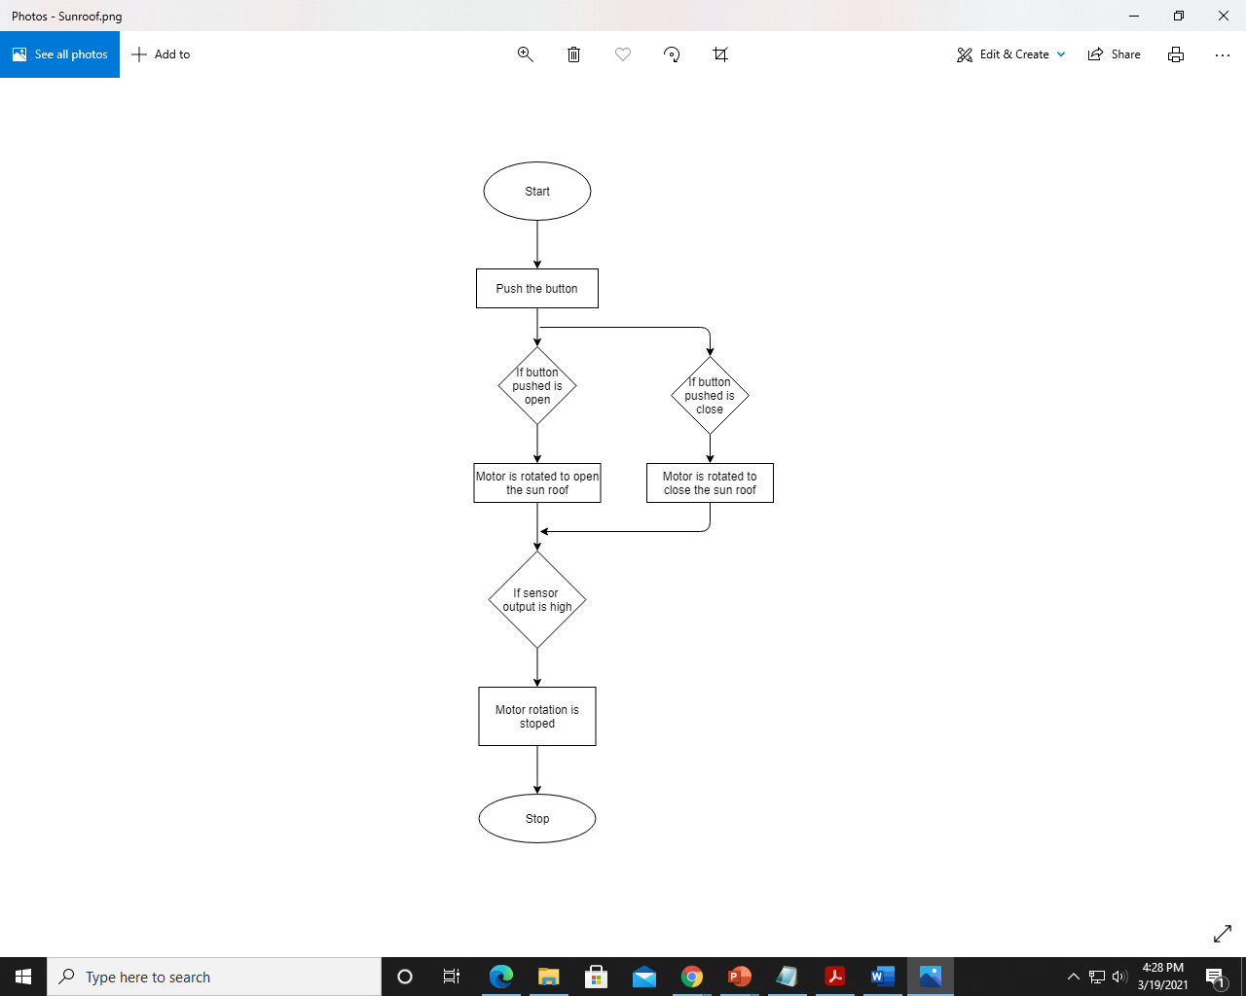

Algorithm for Sunroof control

* + 1. OUTPUT:

The throttle position sensor sends the voltage values to the ECU, which translates the voltages into speeds and displays the speed in the speedometer.

Ex: 85mm Car Boat GPS Speedometer

Characteristics:

* Working Voltage: 9-32V
* Dimension: 85mm
* Range: 0-35knots/0-40miles per hour

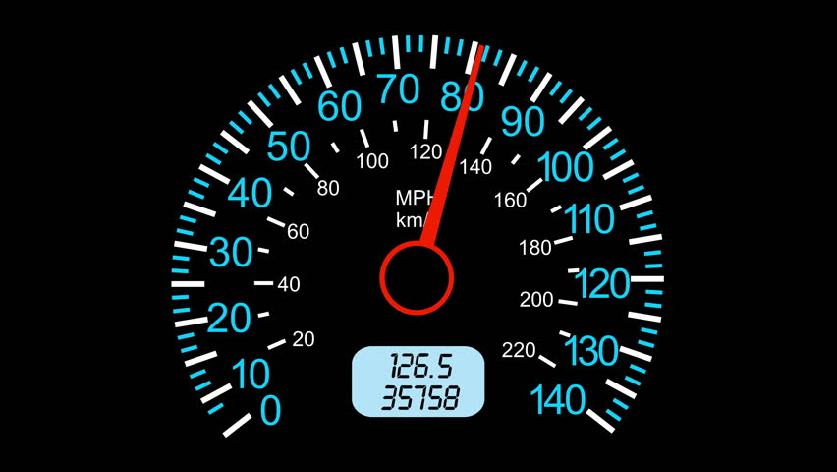

Figure 1.5: Speedometer

* + 1. SWOT ANALYSIS:

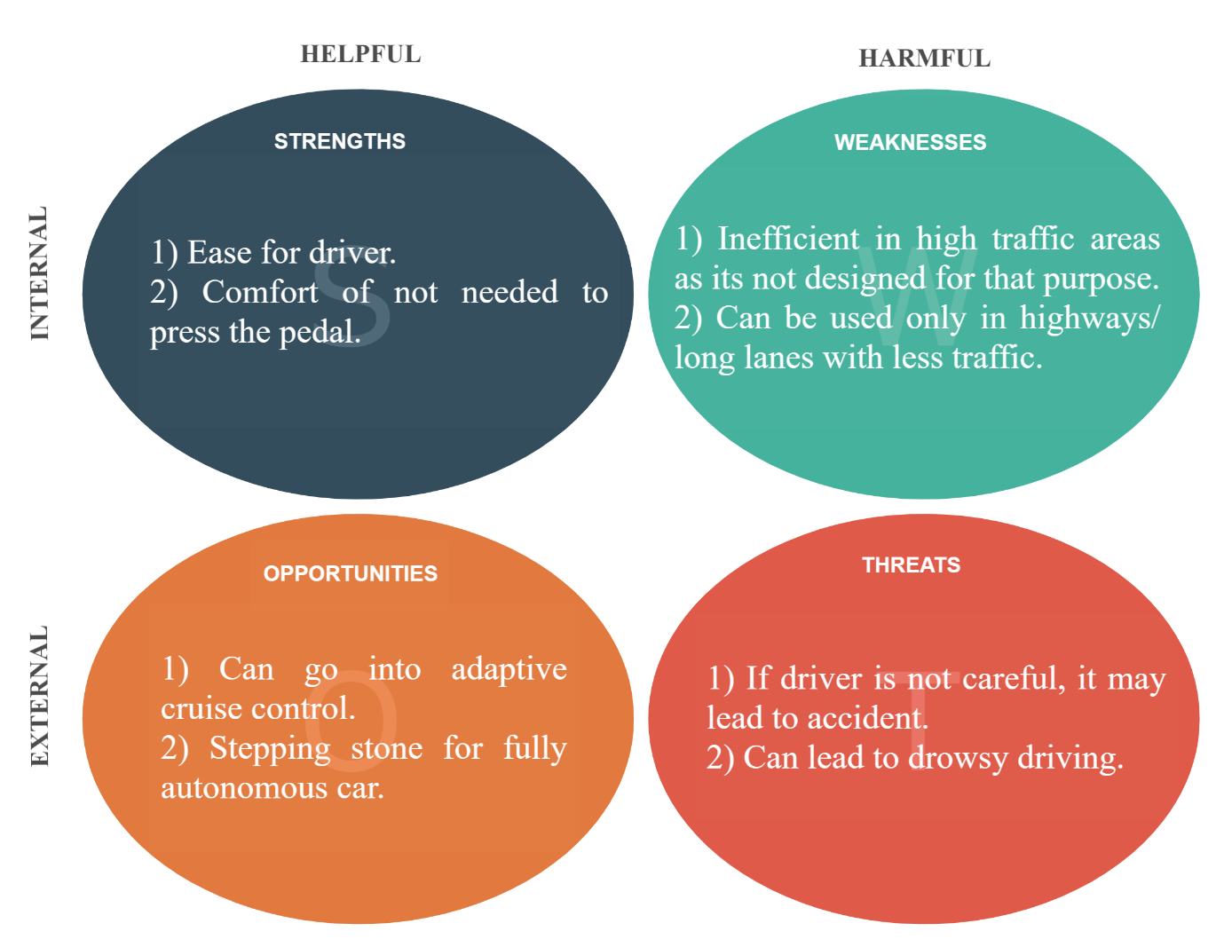

Figure 1.6: SWOT Analysis for Cruise control

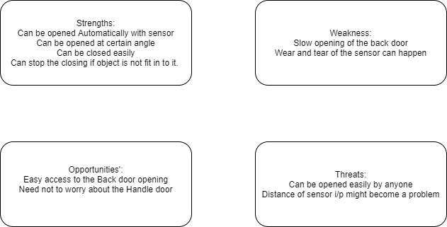

SWOT Analysis for Hatch control

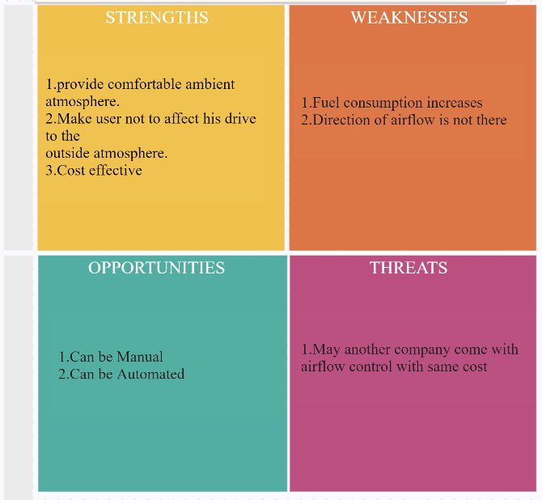

SWOT Analysis for AC control

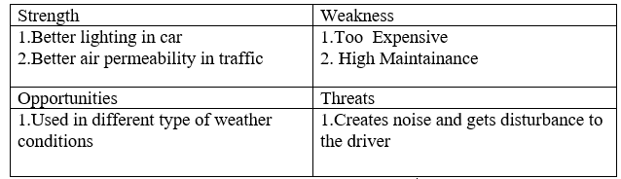

SWOT Analysis for Sunroof Control

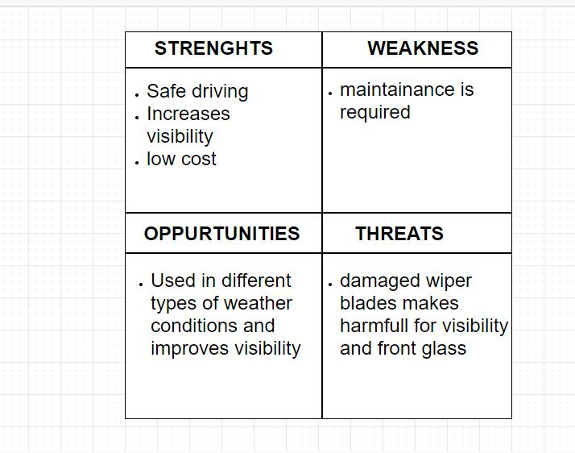

SWOT Analysis for Wiper Control

* + 1. DETAILED REQUIREMENTS:
       1. HIGH LEVEL REQUIREMENTS:

|  |  |
| --- | --- |
| ID | Description |
| H_CC_01 | Cruise control subsystem- The Cruise system was introduced to reduce the driver fatigue for long drives. It is a closed loop control systems. |
| H_HD_02 | Opening of the back door through physical switch and proximity sensor |
|  |  |
|  |  |
|  |  |
|  |  |
|  |  |

* + - 1. LOW LEVEL REQUIREMENTS:

|  |  |
| --- | --- |
| ID | Description |
| L_CC_01 | Cruise control should turn on only if vehicle speed is >40kmph. |
| L_CC_02 | It should hold the vehicle speed at the selected value. |
| L_CC_03 | Hold the speed with minimum surging. |
| L_CC_04 | Allow the vehicle to change speed. |
| L_CC_05 | Deactivate the control immediately after the brakes are applied. |
| L_CC_06 | Store the last set speed. |

# DESIGN & IMPLEMENTATION:

* 1. HIGH LEVEL DESIGN & IMPLEMENTATION:

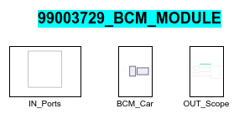

Figure 2.1: HLR of my design

* 1. LOW LEVEL DSEIGN & IMPLEMENTATION:

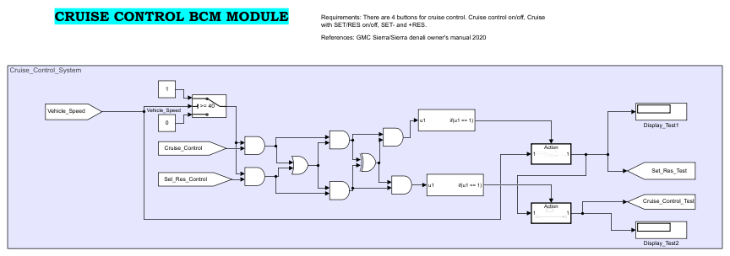

Figure 2.2: Cruise Control design

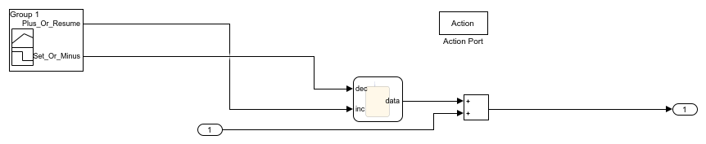

Figure 2.3: SET- and +RES block

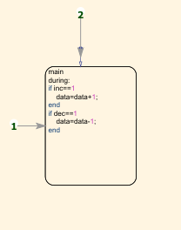

Figure 2.4: Inside the chart of Fig8

# TEST PLAN:

3.1 HIGH LEVEL TEST PLAN:

|  |  |  |  |  |  |  |
| --- | --- | --- | --- | --- | --- | --- |
| Test ID | Description | Input given | Output expected | Actual output | Type of Test | Result |
| H_CR_01 | A speed of 60kmph with cruise control switch in On state is given as input. | 60, Cruise On | 60 | 60 | Requirement based |  |
| HLR_SUN_01 | Open push button pressed | 16v | Sunroof open | Sunroof open |  |  |
| HLR_SUN_02 | Close push button pressed | 16v | Sunroof close | Sunroof close |  |  |
| FW_HL_1 | Enabling front wind shield wiper | Front Wiper should be on | Front Wiper On | Front Wiper On |  |  |
| RW_HL_2 | Enabling rear wind shield wiper | Rear Wiper should be on | Rear Wiper On | Rear Wiper On |  |  |
|  |  |  |  |  |  |  |
|  |  |  |  |  |  |  |
|  |  |  |  |  |  |  |
| HLT_HD_1 | A Button in the driver door and the sensor input should open the hatch at the back |  |  |  |  |  |

3.2 LOW LEVEL TEST PLAN:

|  |  |  |  |  |  |  |
| --- | --- | --- | --- | --- | --- | --- |
| Test ID | Description | Input given | Output expected | Actual output | Type of Test | Result |
| L_CR_01 | A speed of 39kmph given as input. | 39 | Cruise mode should not get activated | Cruise mode doesn’t get activated | Boundary based |  |
| L_CR_02 | A speed of 45kmph given and “+RES” button is pressed 5 times. | 45, +RESx5 | 50 | 50 | Scenario based |  |
| L_CR_03 | A speed of 67kmph given and “SET-” button is pressed 4 times | 67, SET-x4 | 63 | 63 | Scenario based |  |
| L_CR_04 | Previous set cruise control is 55kmph, user turns on the cruise control and presses “SET-”. | SET- | 55 | 55 | Scenario based |  |
| LLT_HD_01 | A Button on the back-door handle is pressed |  |  | Hatch door should open |  |  |
| LLT_HD_02 | A Stop button on the bottom of the door should be pressed. |  |  | Door opening should be closed |  |  |
| LLT_HD_03 | A button on the back-door handle is pressed |  |  | Door operation should pause |  |  |
| LLT_HD_04 | A Button on the bottom of the door should be pressed after pressing the back-door handle button |  |  | Door operation should resume |  |  |
| LLR_SUN_01 | Open push button pressed | 16v | Motor rotates forward | Motor rotates forward |  |  |
| LLR_SUN_02 | Close push button pressed | 16v | Motor rotates reverse | Motor rotates reverse |  |  |
| LS_LL_1 | Enabling Low Speed Wiper | Low Speed Wiper should be On | Low Speed Wiper On | Low Speed Wiper On |  |  |
| HS_LL_2 | Enabling High Speed Wiper | High Speed Wiper should be On | High Speed Wiper On | High Speed Wiper On |  |  |
| M_LL_3 | Enabling Mist condition Wiper | Mist Condition Wiper should be On | Mist Condition Wiper On | Mist Condition Wiper On |  |  |
|  |  |  |  |  |  |  |
|  |  |  |  |  |  |  |
|  |  |  |  |  |  |  |
|  |  |  |  |  |  |  |
|  |  |  |  |  |  |  |
|  |  |  |  |  |  |  |
|  |  |  |  |  |  |  |